**PART A**

**EXPERIMENT NO. 5**

**A.1 Aim: -** To draw the behavioral view diagram: Activity diagram

**A.2 Prerequisite**

Determine the desired flow of action and their interaction with each other

**A.3 Outcome**

After successful completion of this experiment students will be able to -

1. Better understanding of the interaction diagrams.
2. Get familiar with Activity diagram
3. Practice drawing the interaction diagrams using StarUML

**A.4 Theory**

Activity diagrams are flow charts that are used to show the workflow of a system.

They also:

* Represent the dynamics of the system.
* Show the flow of control from activity to activity in the system.
* Show what activities can be done in parallel, and any alternate paths through the flow.

Activity diagrams may be created to represent the flow across use cases or they may be created to represent the flow within a particular use case. Later in the life cycle, activity diagrams may be created to show the workflow for an operation.

Activity diagram notations:

* Rounded rectangles represent activities



* Diamonds represent decisions



* A black circle represents the start (initial state) of the work-flow



* An encircled black circle represents the end (final state).



* Swimlane (vertical)
* Swimlane (horizontal): Swim lane- depicts which human organization is responsible for an activity. Organization – sales, finance, marketing, purchasing etc. Swim lane indicates that activity is performed by a person or persons within the organization.



* Bars represent the start (split) or end (join) of concurrent activities

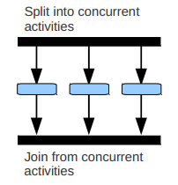

**Activity diagram for uploading photograph:**

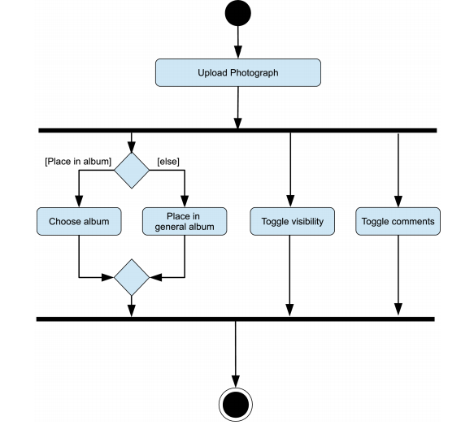

**Activity diagram for stock trading processing:**

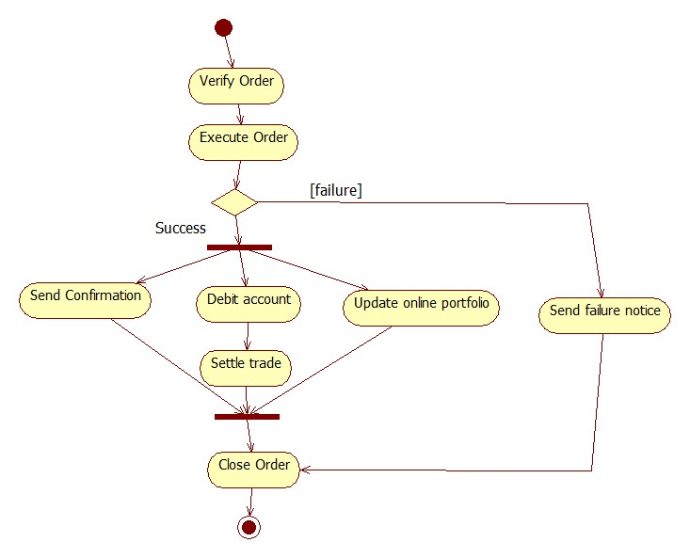

**Activity diagram using swimlane:**

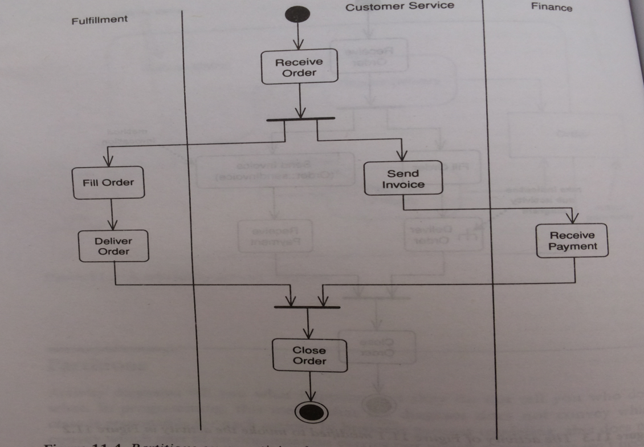

**A.5. Task:**

Draw an activity diagram for the case study.

**PART B**

|  |  |
| --- | --- |
| Roll No: B017 | Name: Niharika Dalal |
| Class: B. Tech. Comp. Engg. | Batch: B1 |
| Date of Experiment: 22.2.2016 | Date of Submission: 29.2.2016 |
| Grade: A+ |  |

**B.1 Activity diagram**

………………………………………………………………………………………………………

Activity Diagram

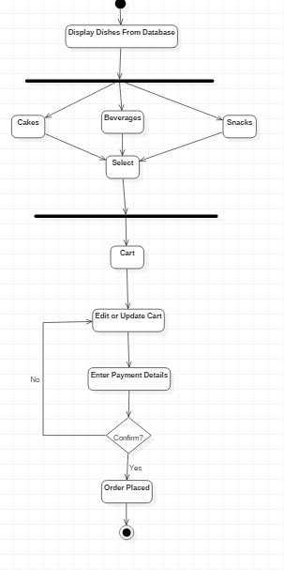

Swimlane Diagram

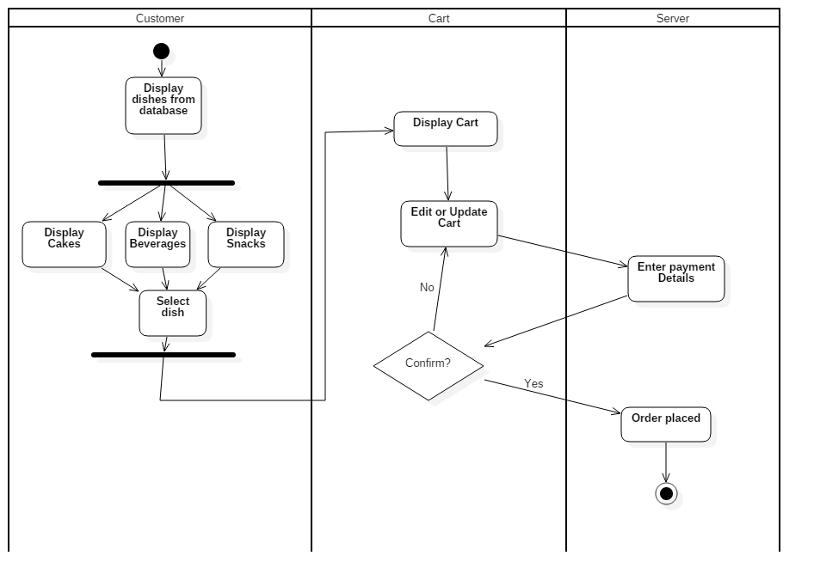

………………………………………………………………………………………………………

**B.2 Conclusion**

………………………………………………………………………………………………………

In this practical, we have made the activity and swimlane diagram for our project.

Activity diagram is basically a flow chart to represent the flow form one activity to another activity. The activity can be described as an operation of the system.

Swimlane diagram is similar to the activity diagram, the only difference is that we segregate entities in swimlane diagram and display their respective functions.

………………………………………………………………………………………………………

**B.5 Questions of Curiosity:**

Q1. What is the primary purpose of activity diagram?

………………………………………………………………………………………………………

Activity diagrams are mainly used to illustrate activities in a system. We use activity diagrams to illustrate the business processes which describe the functionality of the business system.

………………………………………………………………………………………………………

Q.2 State the difference between branches and fork and join in activity diagram.

………………………………………………………………………………………………………

|  |  |  |
| --- | --- | --- |
| BRANCH | JOIN | FORK |
|  | | |
| Branch allows one to choose two or more options. Decision allows one to branch into two actions. Fork allows to branch into two or more actions. | Join node is a control node that has multiple incoming edges and one outgoing edge. | Fork node is a control node that has one incoming edge and multiple outgoing edges. |

………………………………………………………………………………………………………